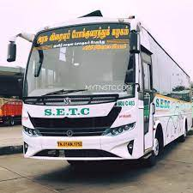

*PUBLIC TRANSPORTATION*

ANALYSIS:

**Comprehensive Study**

Explore the world of public transportation analysis, from setting analysis

objectives to integrating code for effective decision-making.

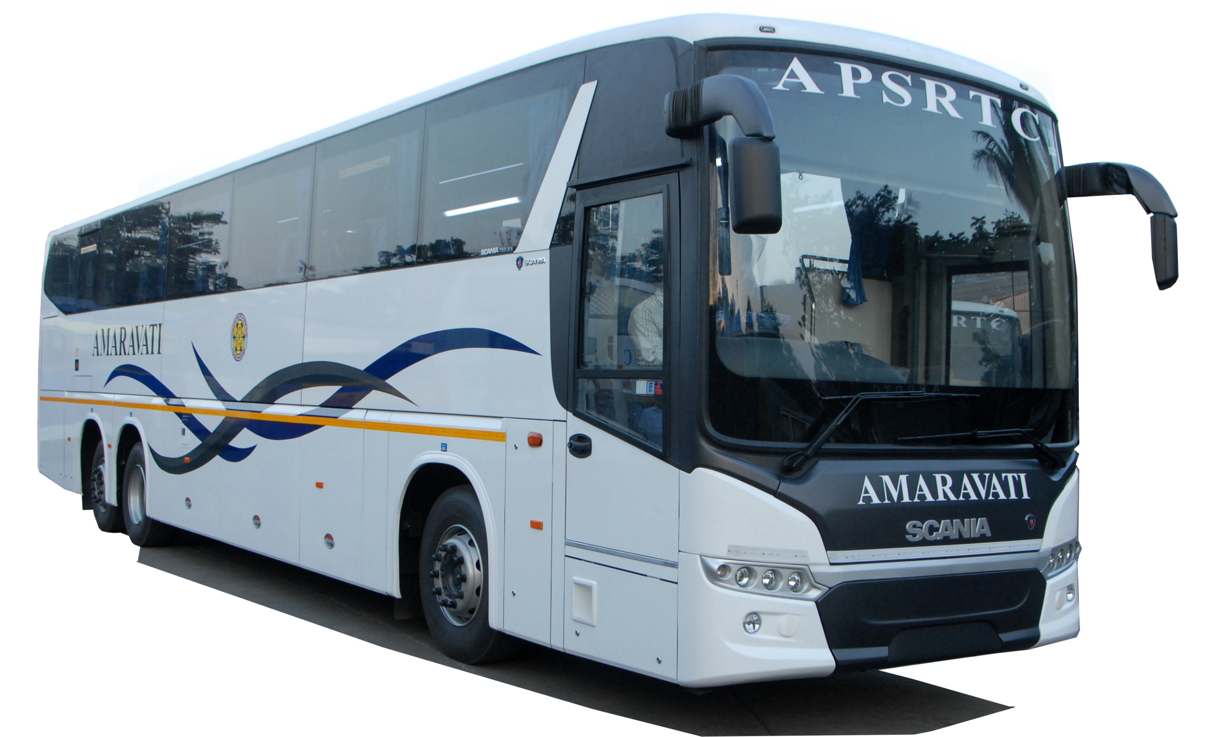

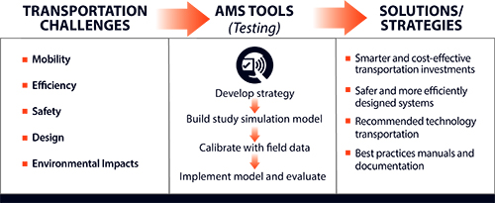

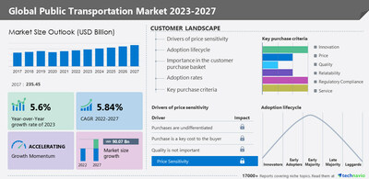

**Analysis Objective:**



**1**

**Optimizing Efficiency**

Analyzing data points to

identify areas for

improvement and increase

the efficiency of public

transportation systems.



**2**

**Enhancing**

**Accessibility**

Examining the accessibility of

public transportation

networks to ensure equal

access for all members of the

community.



**3**

**Reducing Emissions**

Utilizing data analysis to develop sustainable strategies that reduce

environmental impact and promote cleaner transportation.



**Data Collection**

**Survey and**

**Interviews**

Engaging with commuters and

transportation officials to

gather valuable insights and

feedback on the current

system.

**Data Mining**

**Techniques**

Exploring large datasets and

leveraging advanced algorithms

to extract meaningful patterns

and trends.

**Sensor and IoT Data**

Capturing real-time data from

smart sensors and Internet of

Things (IoT) devices to monitor

and analyze transportation

infrastructure.



**Data Visualisation Strategy**



**1**

**Interactive Dashboards**

Creating visually appealing and intuitive

dashboards that allow stakeholders to

explore and understand complex

transportation data.



**2**

**Geospatial Mapping**

Visualizing transportation data on maps

to identify spatial patterns, congestion

hotspots, and optimize route planning.



**3**

**Network Graphs**

Using network graphs to analyze the

connectivity and interdependencies of

different elements within the

transportation system.



**Code Integration**

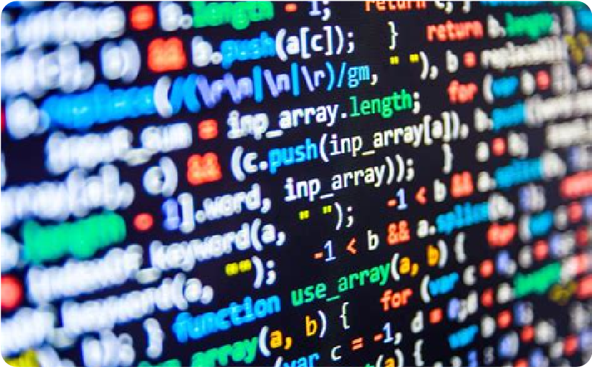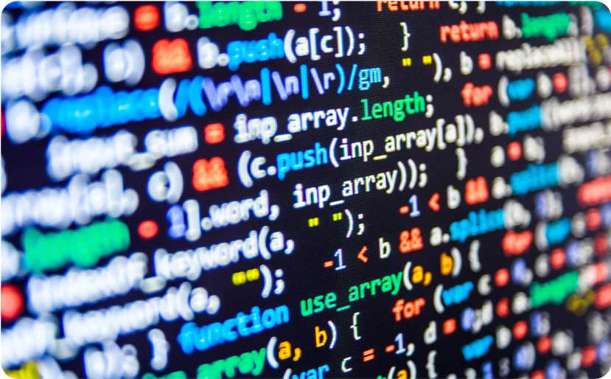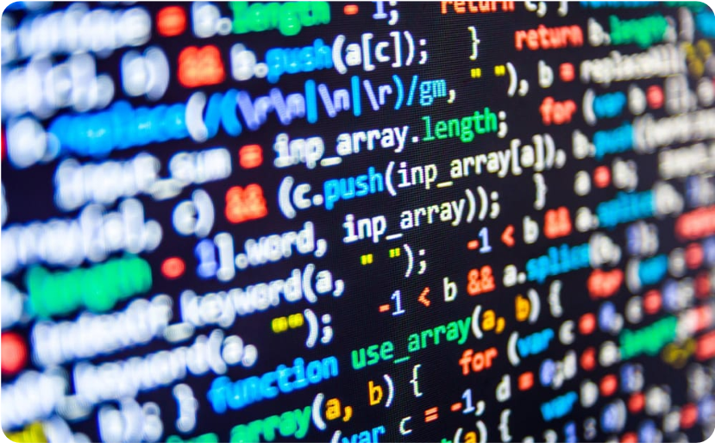

**Automation and Machine**

**Learning**

Integrating code and algorithms

to automate data analysis,

predictive modeling, and

optimization of public

transportation systems.

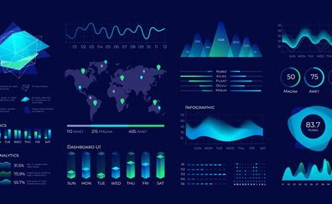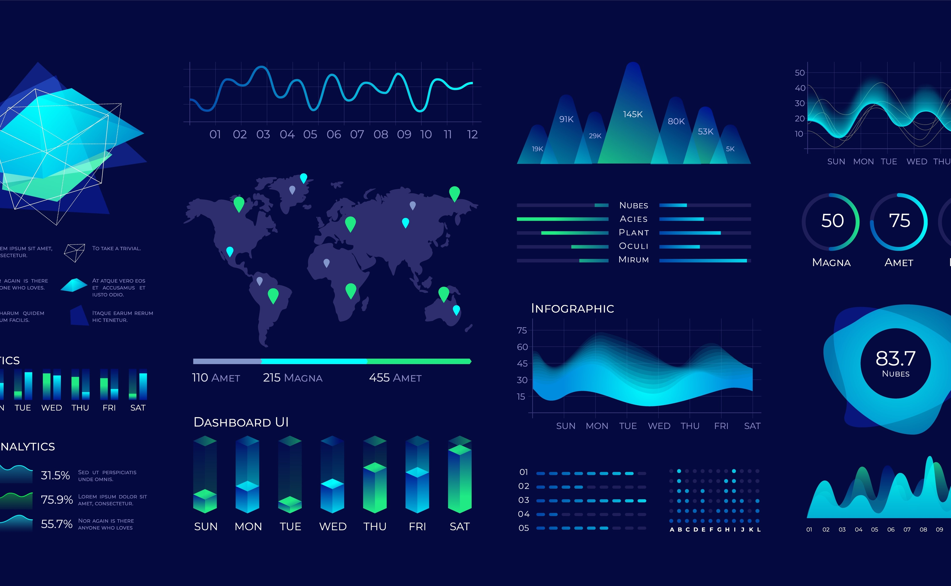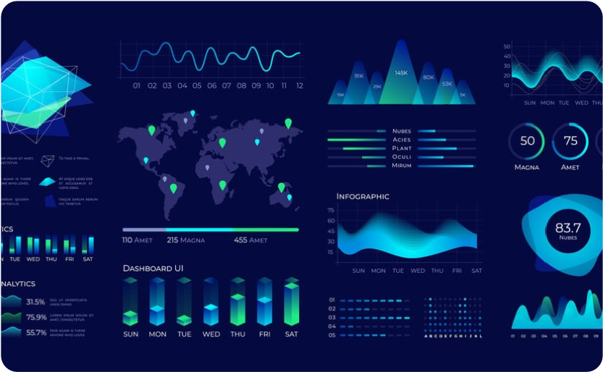

**Data Visualization**

**Libraries**

Leveraging powerful data

visualization libraries to create

informative and visually appealing

representations of public

transportation data.

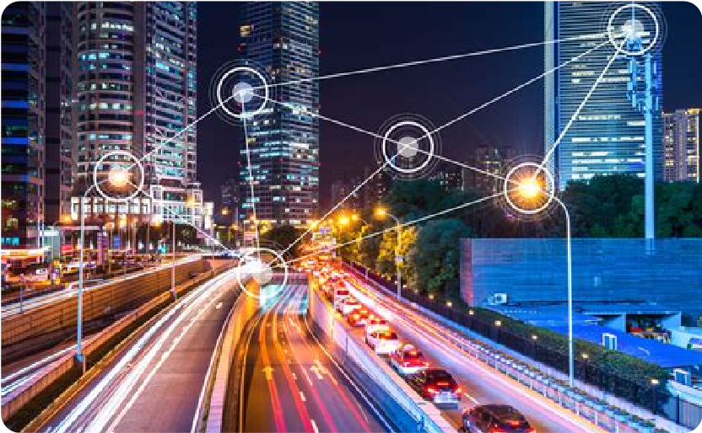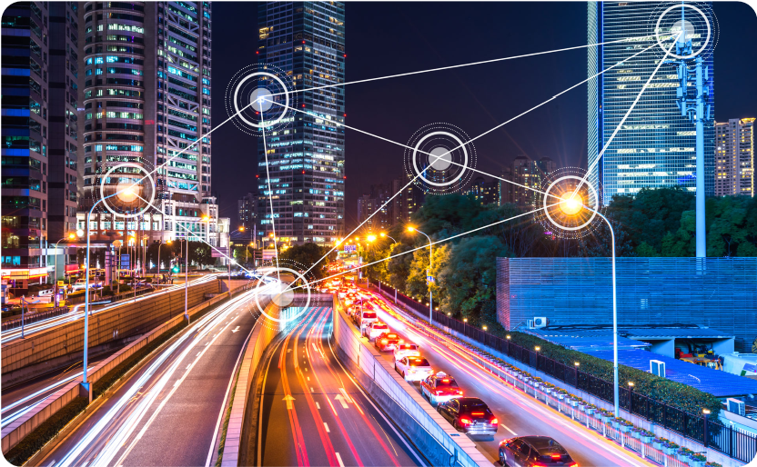

**Smart City Integration**

Integrating transportation

analysis with other smart city

initiatives to enhance overall

urban sustainability and livability.



**Conclusion**

Transportation analysis plays a crucial role in optimizing efficiency,

accessibility, and sustainability of public transportation systems.

Data collection techniques and visualization strategies provide valuable

insights for decision-making.

Integrating code and smart city initiatives can lead to transformative

improvements in urban transportation.

